https://libertyartvietnam.blogspot.com/2014/10/normal-0-false-false-false-en-us-x-none.html

Dang Hai Son

Nguyen Xuan Khanh - (B. 1969 Hai Phong - D. 2001 Saigon)

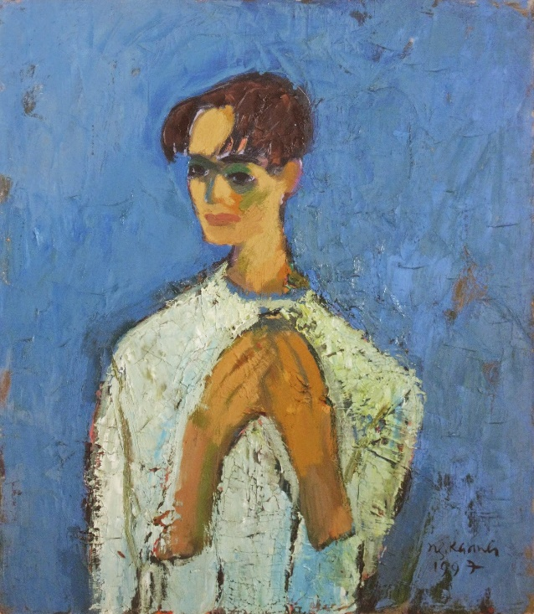
Nguyen Xuan Khanh - Self Portrait - oil on canvas - 75x65cm
NGUYEN XUAN KHANH

Born: 1969, Hai Phong City, Vietnam
Death: 2001, Saigon, Vietnam

Khanh has loved painting since he was a little boy; so he asked his parents to let him join the club for gifted children in Hai Phong City. Although his father didn’t fully agree, Khanh received strong support from his mother. His father at last acquiesced to his wife and child.
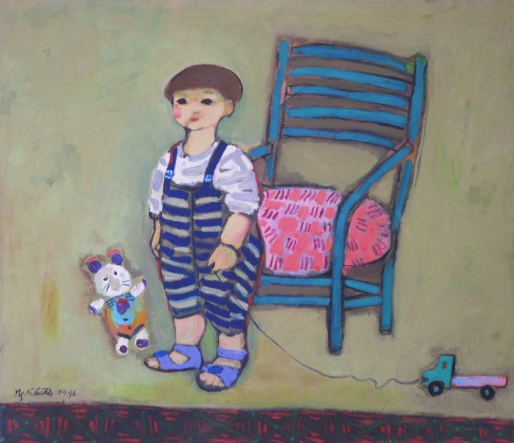
Nguyen Xuan Khanh - My Son - oil on canvas - 83x96cm

The class for gifted children taught them to draw daily-life objects such as a rice bowl, tea cup, a leaf...It took a long time for most children to accomplish the lesson. For Khanh, however, those were simple exercises.
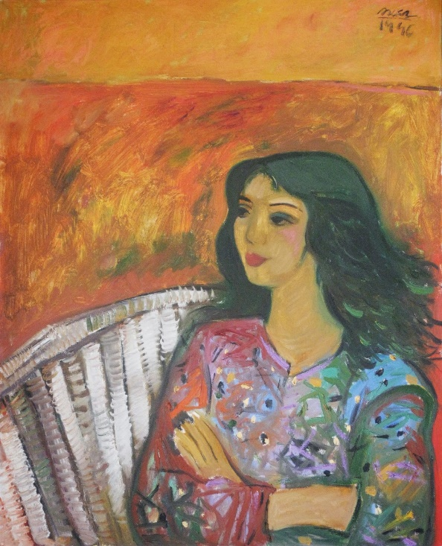
Nguyen Xuan Khanh - Portrait - oil on canvas - 80x65cm

Khanh's gift for drawing led him to a job with a renowned and pernickety reproduction ceramics producer in Hai Phong City. His finesse allowed him to reproduce subtle textures of ceramic from Tsung, Yuen, Tang era. The pay wasn’t bad, but Khanh didn't want to be a copyist. His dream was to be a visual artist.
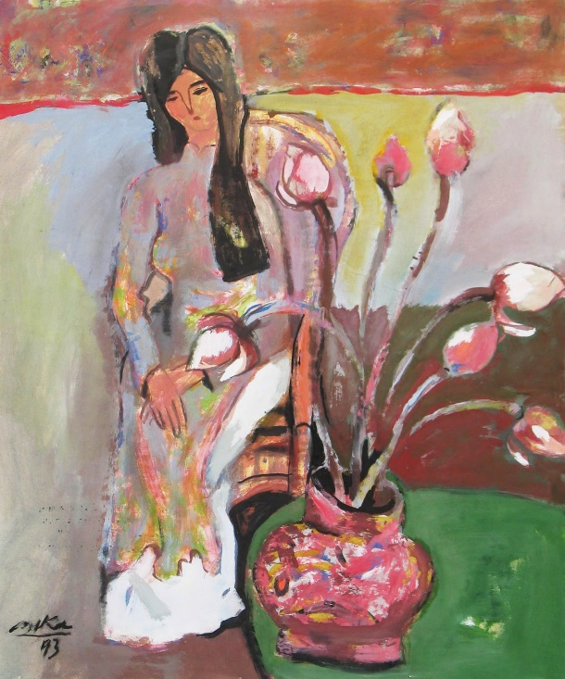
Nguyen Xuan Khanh - Young Girl and Lotus - Gouache on paper - 70x60cm

Khanh's father was a high school teacher in Hai Phong. He was the younger brother of Mr. Nguyen Xuan Vinh, the former commander of the Vietnam Republic Air Forces under President Ngo Dinh Diem (South Vietnam). With such identity, it was not easy for him to to keep his post on the pulpit in North Vietnam before 1975. That background caused several troubles for Khanh as well. His father always kept this problem in mind. Because Khanh was also gifted in mathematics, his father hoped Khanh could go far in Sciences. But with Khanh, family background was no matter; he only liked painting and wished to become a visual artist.
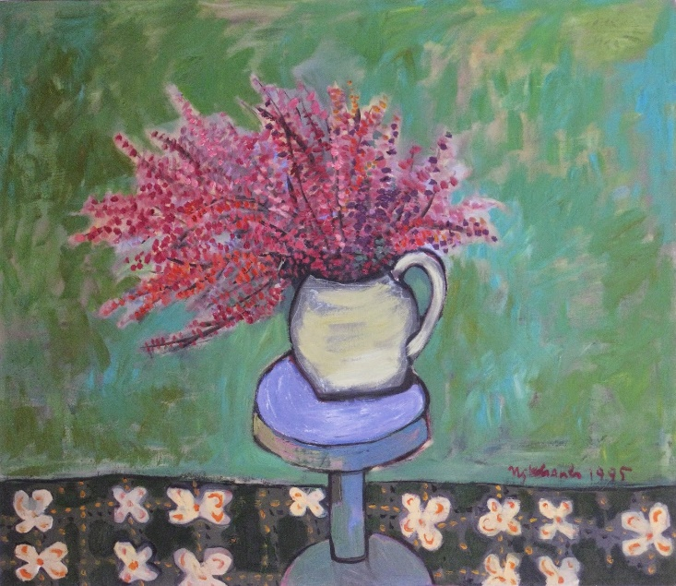
Nguyen Xuan Khanh - Flowers - oil on canvas - 83x96cm

Khanh participated in many art exhibitions in Hai Phong City such as exhibitions for children, for young artists, for stable and renowned artists. Hai Phong senior artists used to consider Khanh as a young fellow of their artistic group.
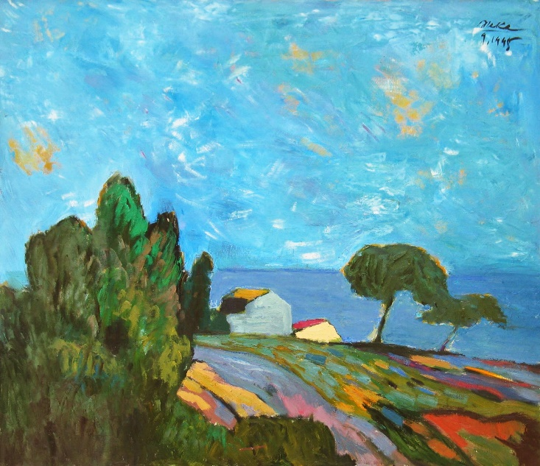
Nguyen Xuan Khanh - Landscape - oil on canvas - 83x96cm

At a two men show together with artist Dao Hai Phong in Hanoi in 1990, 2 gouache drawings by Khanh were sold at US$200. It was the first time Khanh earned money from his art-works, and it was a great sum in the northern of Vietnam at that time.

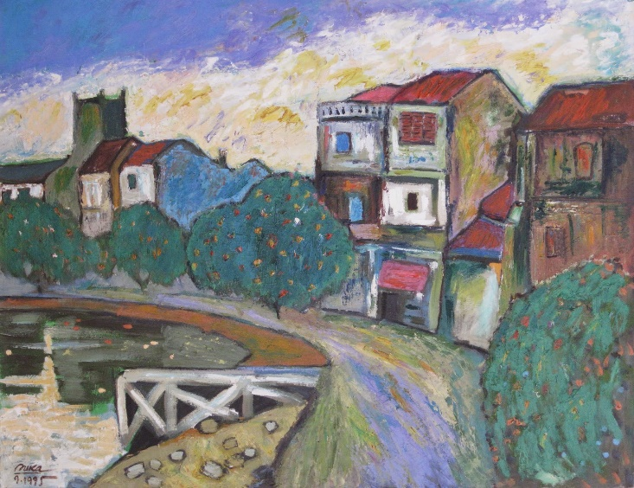
Nguyen Xuan Khanh - Tam Bac Riverside - oil on canvas - 91x117cm

In 1993, Khanh was awarded Nguyen Binh Khiem Prize of Hai Phong City.
In 1993, Khanh got a job as illustrator and designer for the magazine THE GIOI MOI (NEW WORLD) of National Education Department, and moved to Saigon. The magazine office was only 100 meters away from Tu Do (Liberty) Gallery. Thanks to that, we could canvass Khanh's works since his first week in Saigon.
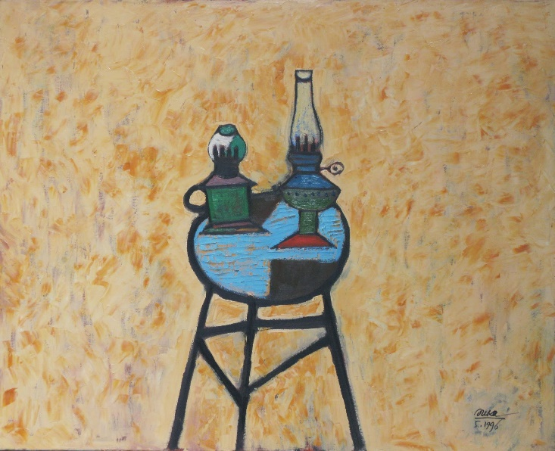
Nguyen Xuan Khanh - Two Kerosene Lamps - oil on canvas - 65x80cm

Khanh brought in all his works from the North: about 50 gouache and water color on paper drawings. Most of them were landscape, seascape; a few were human and still life. The quantity of each category demonstrated Khanh's forte in landscape, especially his exquisite and inspiring rendition of Tam Bac river. Tam Bac is the river which bisects Hai Phong City.

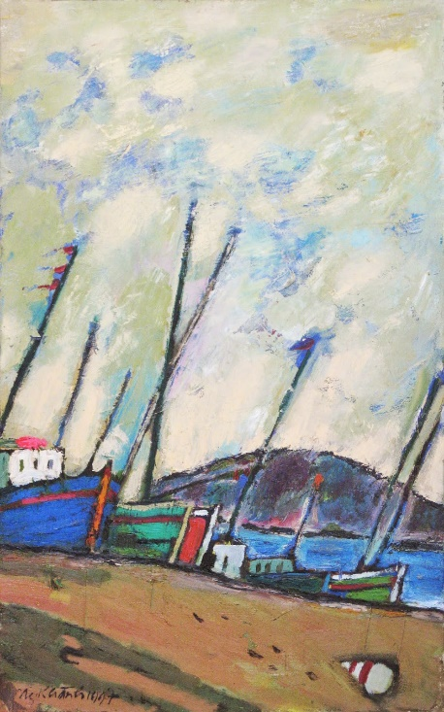
Nguyen Xuan Khanh - Boats - oil on canvas - 80x50cm

With artistic view, Khanh conveyed a sincere love for his hometown with floating boats on the river, and houses along the banks. Khanh's works spoke his own language and soon became popular. More than half of the drawings Khanh brought to Tu Do Gallery were sold in the first month.
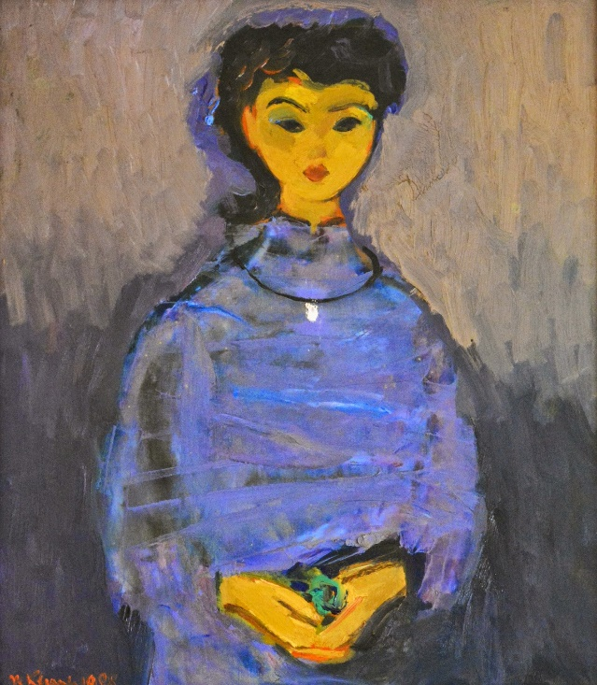
Nguyen Xuan Khanh - Portrait - oil on canvas - 75x65cm

I proposed Khanh to try his hand with oil color. Marvelously! Khanh succeed with the very first oil painting. Khanh's oil landscapes were deeper, more sparkling and lively than his gouaches and water color. Khanh's portraits were also so charming, his still lives and flowers, dainty.
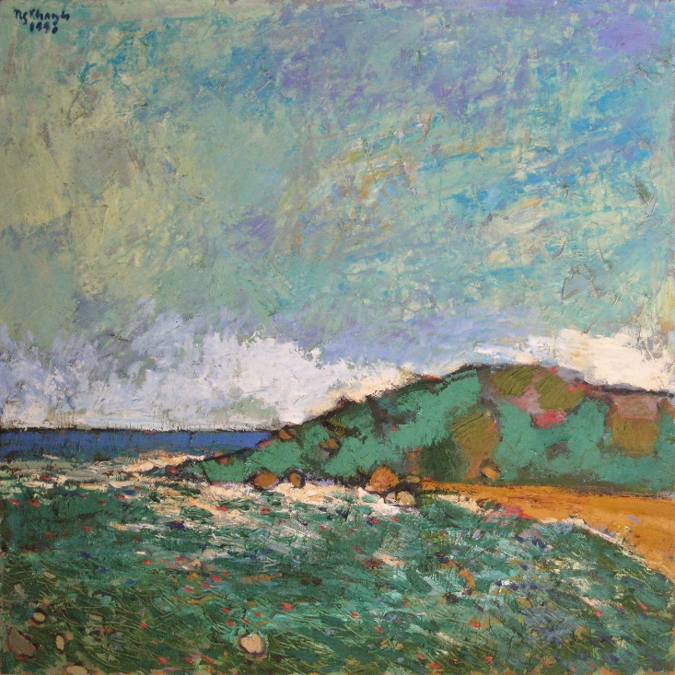
Nguyen Xuan Khanh - Seaside - oil on canvas - 100x100cm

Khanh threw broad brush strokes, full of self-confidence, with lively and bright colors. Khanh used crude and antagonistic colors such as blue, green, red, yellow...then he created intermediary with soft light shadow lines, harmonizing the oppositions of colors. Nguyen Xuan Khanh's oil paintings were soon welcomed by art lovers, especially by serious collectors.
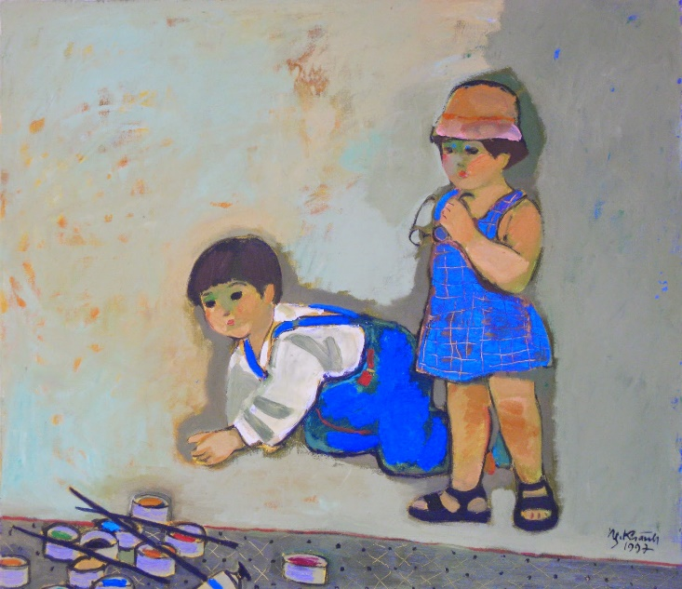
Nguyen Xuan Khanh - Two Friends - oil on canvas - 83x96cm

Nguyen Xuan Khanh's art is a beautiful union between Impressionism and Fauvism. Whether it was a scene of splendor dawn at sea, or a bright slanting sun-beams floodlighted on a lonely shrine at the top of a hill; all of them were magnificent, charming and romantics. Khanh drew comfortably like a virtuoso musician who already mastered his instrument. He didn't have to pay any attention to technique and let his soul fully immerse with the sounds of music. Observing Khanh working, I felt as if the brush in his hand had been totally forgotten and Khanh was stretching his soul onto the canvas.
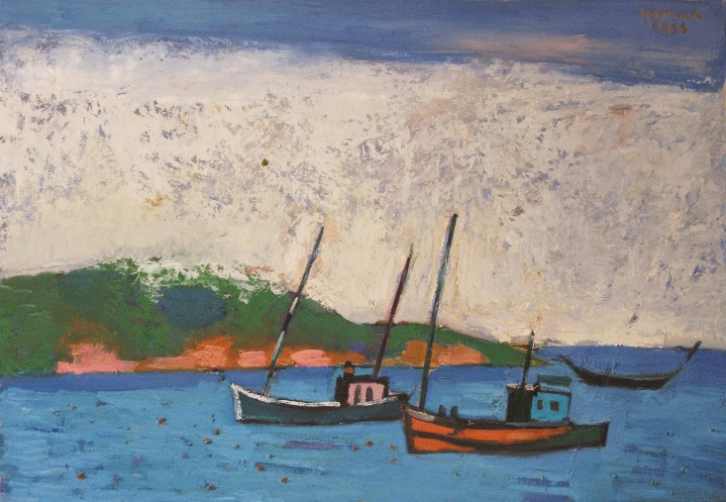
Nguyen Xuan Khanh - Boats and Sea - oil on canvas - 65x95cm

When asked why he preferred landscape to other categories, Khanh answered “Because I love graceful sceneries, at times they were so stunning that I wished to lay down my life so my last moment would be one of sublime beauty.
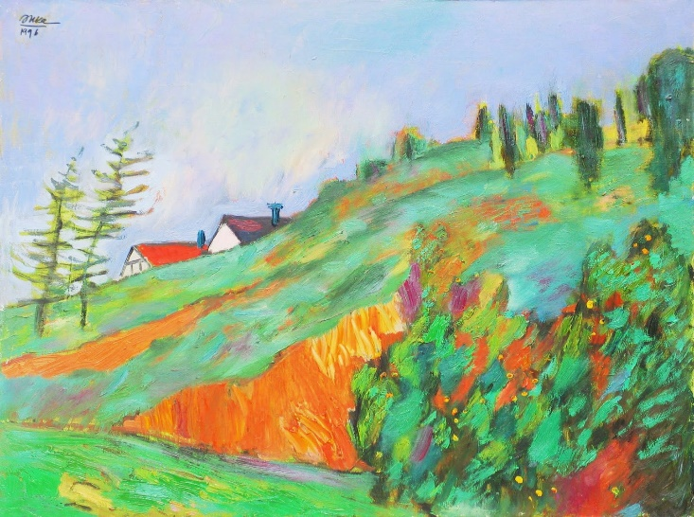
Nguyen Xuan Khanh - Highland - oil on canvas - 60x80cm

Khanh quit his good job at NEW WORLD Magazine to reserve all of his time and mind for artistic works.

Khanh held many painting exhibitions in Vietnam. His first exhibition abroad occurred in 1997 at H&S Gallery in Brussels, Belgium. His second exhibition outside of Vietnam was at Atrium Gallery, Melbourne, Australia in 2000. Both those exhibitions were successfully in terms of finance as well as public opinion.
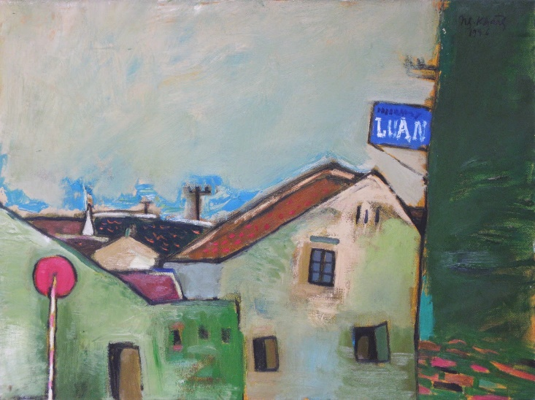
Nguyen Xuan Khanh - Street - oil on canvas - 59x79cm

Only a few months after his exhibition in Melbourne in 2000, Nguyen Xuan Khanh passed away on 20 March 2001, after a traffic accident at Seventh District, Saigon. He was 32 years old at that time.
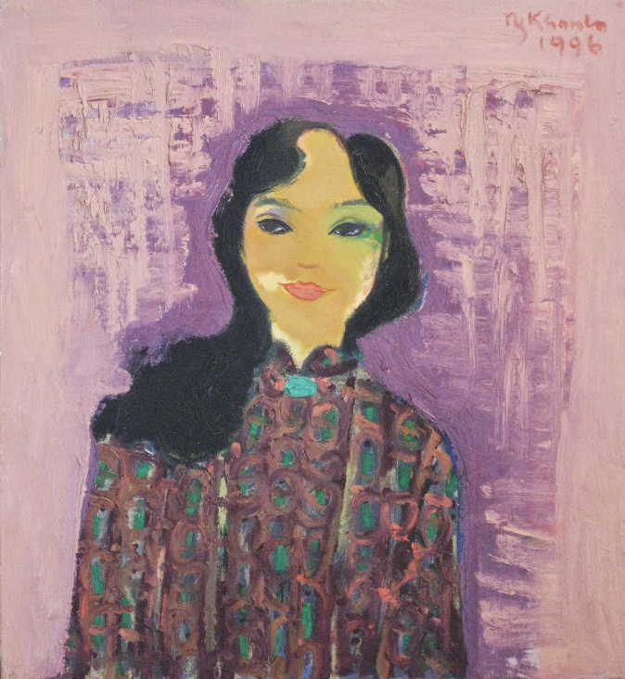
Nguyen Xuan Khanh - Portrait - oil on canvas - 60x55cm

From 1993 until his last day, Nguyen Xuan Khanh was a professional artist, lived by his art works. Khanh created about 400 artworks during this period. Most of them are oil on canvas; 70 percent of which had been collected by art lovers through Tu Do Gallery.

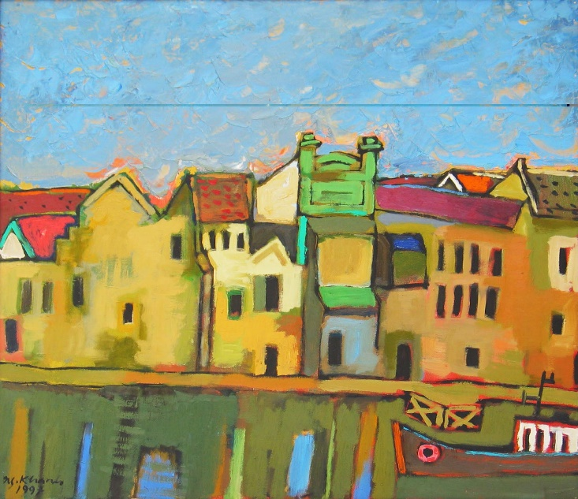
Nguyen Xuan Khanh - Tam Bac River - oil on canvas - 83x96cm

I hope there would be some further studies which evaluate Nguyen Xuan Khanh's art fairly and thoroughly.

San Francisco
1-October-2014

